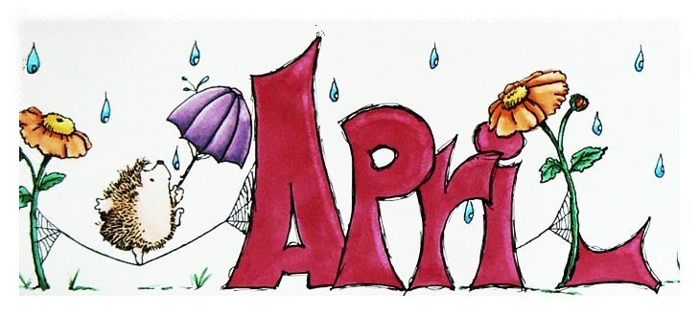
Ms.Susana and Ms. Lena

It is exciting to slowly see springs begin to blossom! We are beginning to take off our coats and put on our light. This month I’m excited to bring some lessons, stories, songs, and craft ideas from my home to yours. We will continue to explore our clothing study together with great stories and activities you can try at home. Please continue practicing your cutting and lacing skills. We will explore the different textures of clothing, various uniforms people wear to different jobs, and how our clothing may be different in different countries. Our math focus will be various forms of measuring, creating patterns, sequencing, and sorting. We will also begin a fun bean planting experience. Please provide your child with any dry bean that you may have an interest in growing. We will keep a record of its growth throughout the spring. Please continue to look through our website to get activity ideas. You may want to visit various classrooms for fun ideas. We can still have fun and discover new things while staying safe inside!

Stella- 3rd
Grace- 3rd
Isabel- 28th

Dates to Remember
1st- April Fool’s Day
10th-Good Friday
12th -Easter
22nd- Earth Day

