Rain in a jar Science Experiment

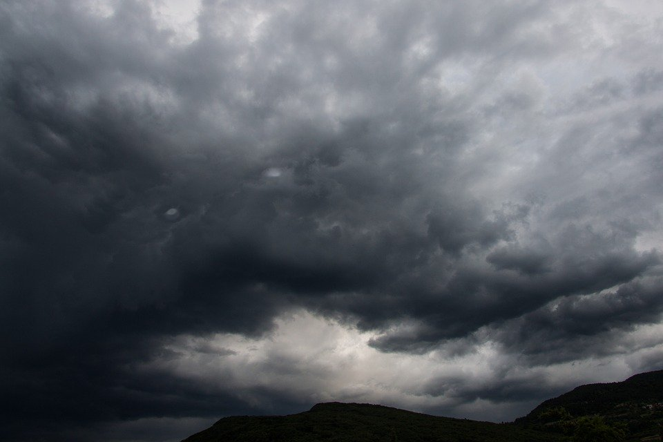
Clouds are made of tiny droplets of water. As the droplets get bigger and heavier in the cloud they fall to the ground. Big droplets are called rain. Little droplets are called drizzle.
In our experiment the food coloring drops made the shaving cream heavy with moisture. The food coloring droplets fell into the jar when they became too heavy for the shaving cream.

- How many drops of food coloring will you need to make rain in the jar?
- Can you use a different color for your rain?
- What happens to the food coloring when it drops in the water?
- Can you see through the rain?
- What other materials can you use to make a cloud?

