POPSICLE STICK SHAPE PUZZLES
This activity is easy to make and requires 2 materials- 1. Thick popsicle sticks and 2. Colored markers
Please supervise your child when completing this activity together.
MATERIALS:
–Thick popsicle sticks
–Colored markers (preferably permanent markers)

INSTRUCTIONS:
1.Line up 3 popsicle sticks together
2. Draw a large shape using the colored markers.
-Make as many shape puzzles as you want (such as a triangle, square, rectangle and circle) and use different bright colors for each shape.

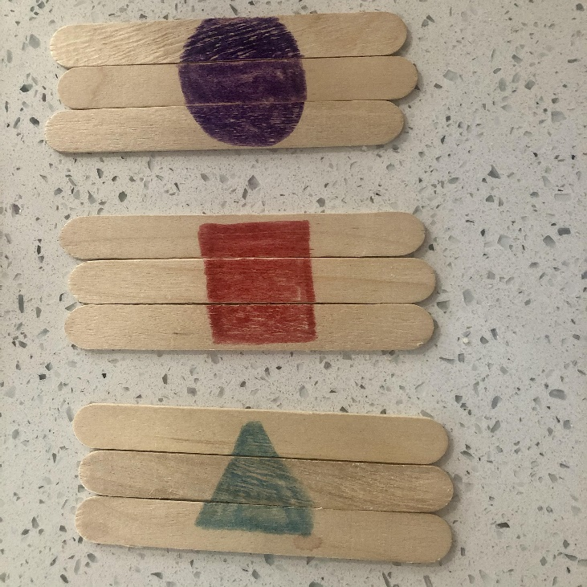
Hope you and your child have fun with this activity and send pictures of your puzzles if you would like!

