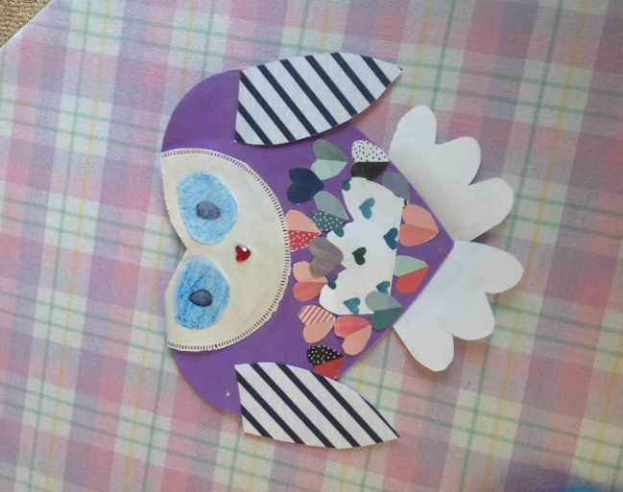
Hi Everyone! Here is a picture of my craft I made of my favorite animal. My owl is named Love. She has striped wings, she can fly, and she lives in a forest filled with heart shaped trees. When you are feeling sad Love will fly to you and leave a heart shaped feather from her belly. Love wants to remind everyone to be kind.
<3 Miss Lauren
Materials I used:
- Scrapbook paper
- Doilies
- Tape
- Scissors
- Gem heart sticker
- Crayon and marker (not pictured)
