Muffin Tin Math
Print muffins and numbers(table)
- Have your child cut out the muffins and numbers from the table
- Glue the numbers with matching dots on the muffins
- Place the muffins in the muffin tins
- Use marbles to count and match the numbers on the muffins
Keep counting! How high can you count? If you do not have marbles what can you use to count in the tin? What type of muffins did you bake?
This activity could also be done by sorting colors, letters, and shapes!
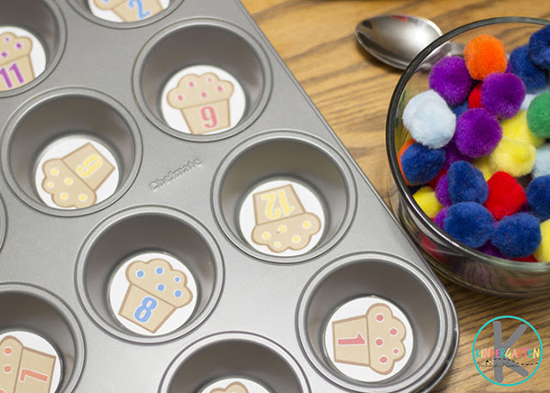 Here is an example of the muffins in the tin with the numbers and correlating dots.
This Photo by Unknown Author is licensed under CC BY-SA
This Photo by Unknown Author is licensed under CC BY-SA
This Photo by Unknown Author is licensed under CC BY-SA
This Photo by Unknown Author is licensed under CC BY-SA
This Photo by Unknown Author is licensed under CC BY-SA
This Photo by Unknown Author is licensed under CC BY-SA
This Photo by Unknown Author is licensed under CC BY-SA
This Photo by Unknown Author is licensed under CC BY-SA
This Photo by Unknown Author is licensed under CC BY-SA
This Photo by Unknown Author is licensed under CC BY-SA
This Photo by Unknown Author is licensed under CC BY-SA
This Photo by Unknown Author is licensed under CC BY-SA
This Photo by Unknown Author is licensed under CC BY-SA
This Photo by Unknown Author is licensed under CC BY-SA
1  . | 2  . . | 3  …
4  …. | 5  ….. | 6  ……
7  ……. | 8 …….. | 9  ………
10  ………. | 11  ……….. | 12  …………

