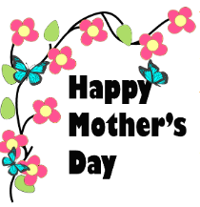

Dear Parents,

Welcome to the month of May! During the month of April, we learned about caterpillars and butterflies. We counted 4 circles to make a caterpillar. We made a fun and healthy caterpillar snack from cucumbers, blueberries, raisins, and celery. We also learned about recycling and making new things from something old. We made a drum using an oatmeal container and a school bus from an egg carton. We also had Zoom meetings. It was very exciting to see my friends, sing along, and read stories.

During the month of May, we will be learning about shapes. We will be celebrating Mother’s Day, learning about farm animals, and community helpers. We will also be planting flowers if weather permits. I would like to thank all parents for their cooperation and support by watching our videos and extending learning at home during these challenging times. I would also like to thank Ms. Rose, Ms. Neidy, and Ms. Evelin for their cooperation to help make this possible.

As always, thank you for your support. Stay healthy and safe. Please reach out if you have any questions or suggestions.

Sincerely,

Ms. Jackie

**Video Topics:**

**Week of May 4th:** Shapes/ Mother’s Day

**Week of May 11th:** Farm Animals

**Week of May 18th:** Planting Flowers (weather-permitting)

**Week of May 25th:** Community Helpers

A-1 May Newsletter