Let’s make tape resist art using the first letter of your name!
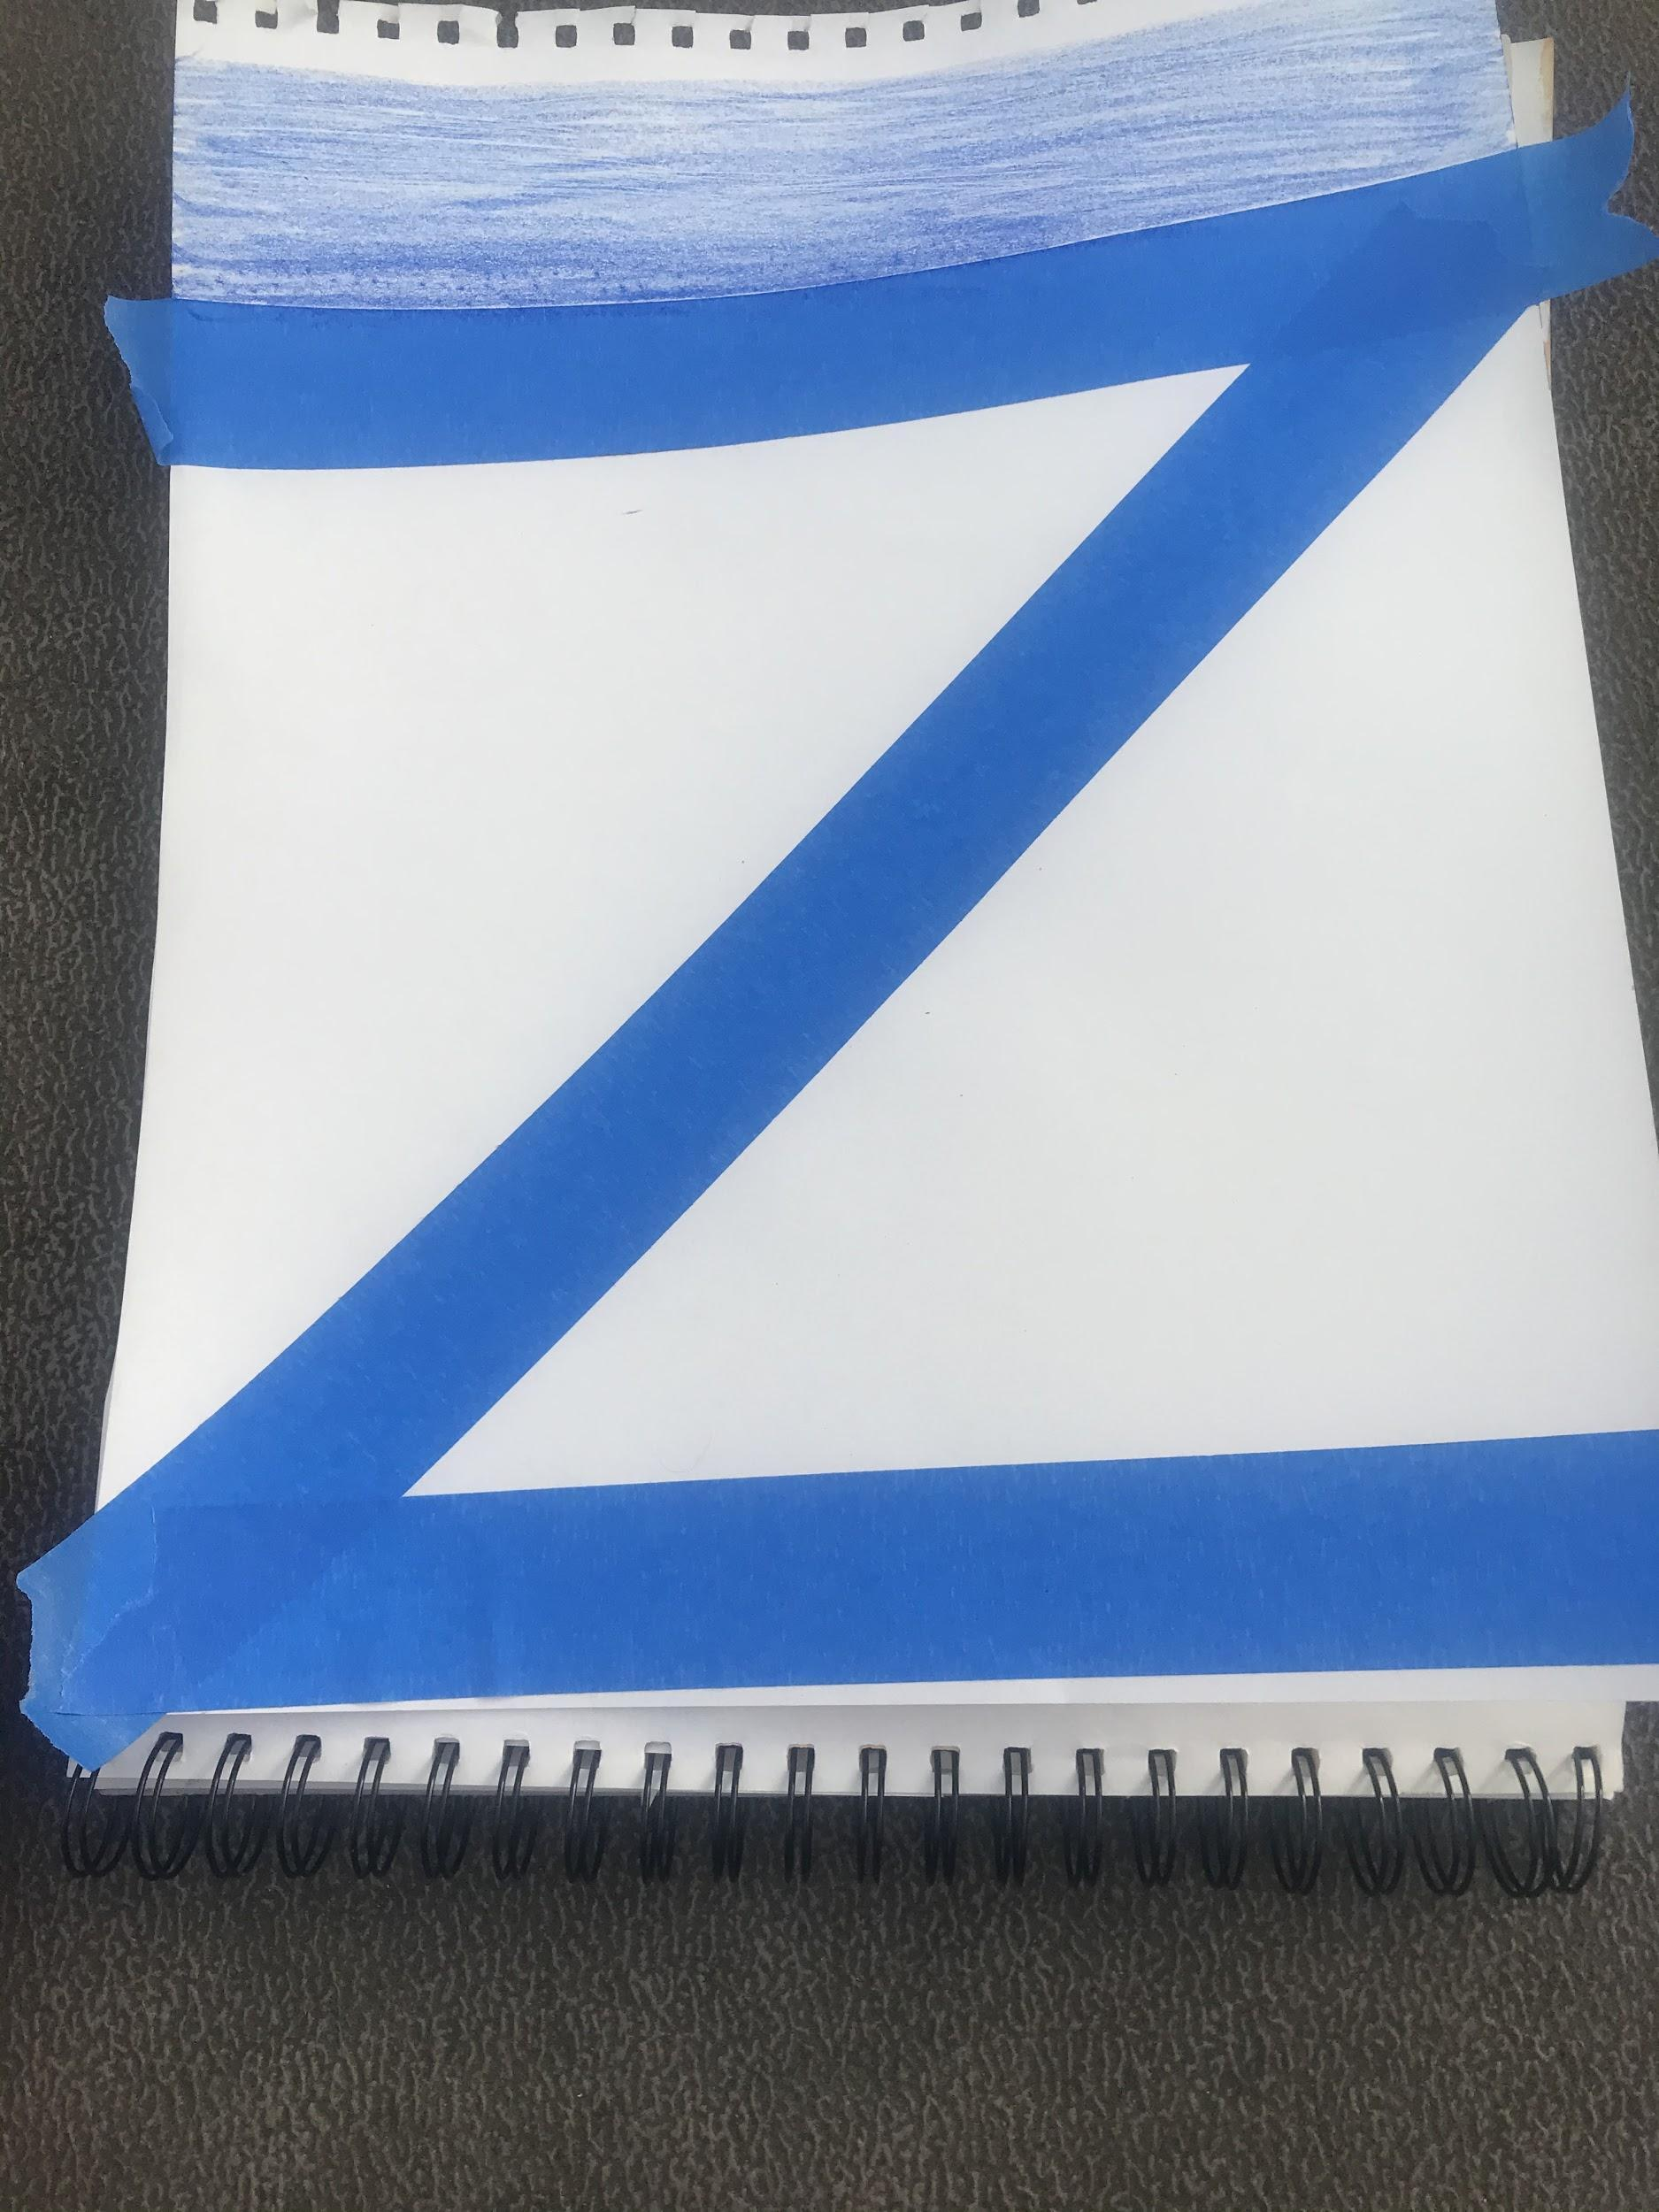
- What sound does the first letter of your name make?
- What other things make that letter sound?
- Find an object in your home that makes the same sound as the first letter of your name. Example: Zoey would look for a zebra or the number zero.

*How to do this activity*
- Place down your tape to make the first letter of your name
- Using markers or crayons, color your paper
- Try your best to color in any white spots showing on your paper
- Carefully peel off your tape to reveal your masterpiece

