Letter Bb Collage
Materials: Magazine, Glue Stick, Scissors, Paper, and Marker
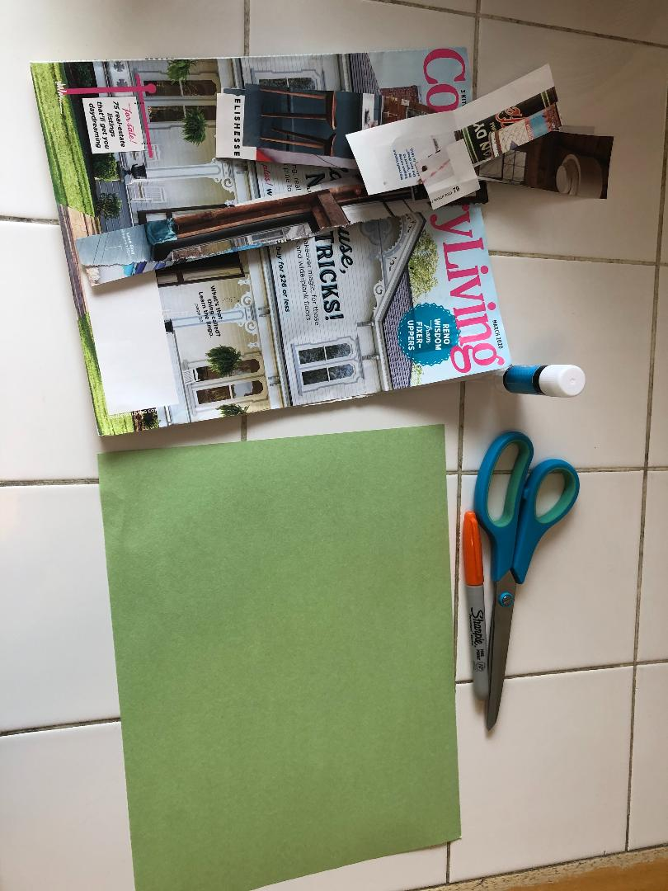
Write Uppercase and Lowercase Bb on the paper. Have your child trace the letters with any tool he/she chooses.
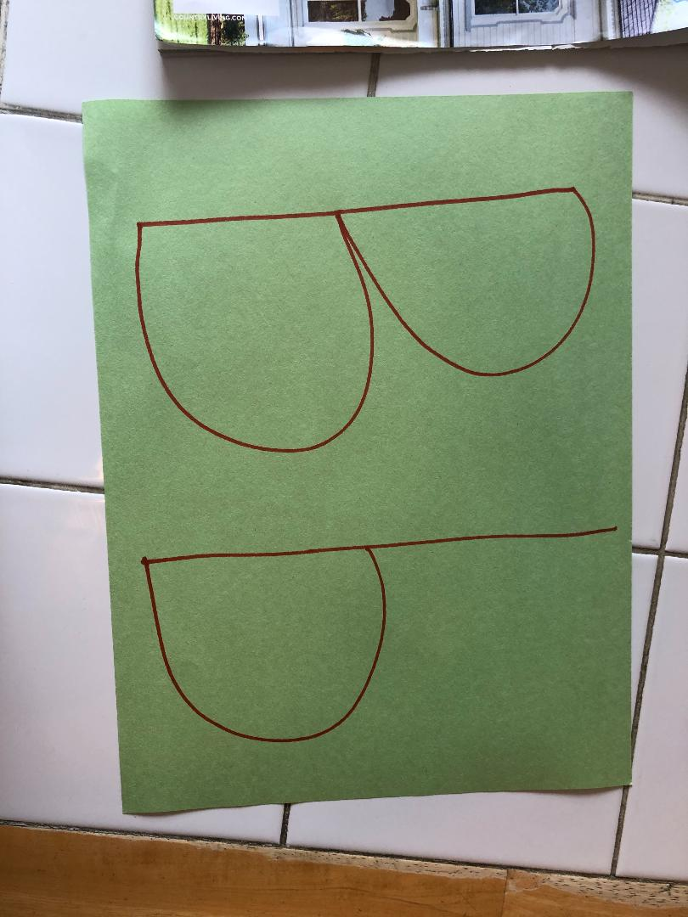

Go on a letter Bb hunt! Search through the magazine together and find pictures of objects that begin with letter Bb! Cut out the pictures and glue them on your letter paper! Do not forget to label the pictures!
*How many objects did you find? Let us count.
*What is your favorite object?
*Can you find any of the objects in your home?

Here is my letter Bb collage. My favorites are the book and blanket. 