Ice Cream Quantifying (please print) 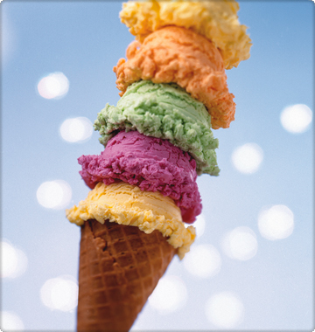
- Have your child count the numbers on the ice cream cones
- Find objects in your house to quantify and match the numbers on the cones. (below)
- Fill in the blank cones with higher numbers to challenge your child
