Healthy/Unhealthy Food Sort 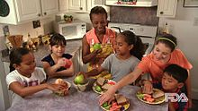
During snack/lunch time in our classroom, we discuss the different foods our friends are eating. We ask each other a few of these questions.
- Is your food healthy or unhealthy?
- How do you know the difference?
- How can we make healthier choices?
- How do healthy foods help our bodies?
- How do unhealthy foods make us feel?
- What is your favorite food from each group?
Draw, paint, print, or cutout pictures of healthy and unhealthy foods. Sort the foods into two groups.
Group 1. Healthy Foods
Group 2. Unhealthy Foods
Below is an example of my food sort! Yummy!

- Healthy 2. Unhealthy
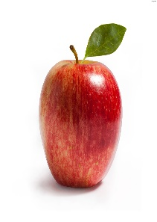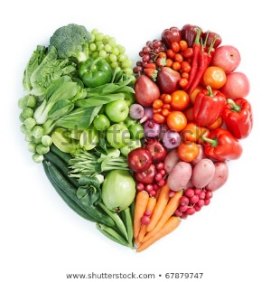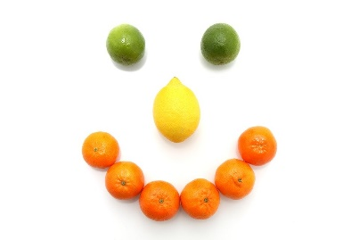  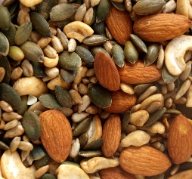  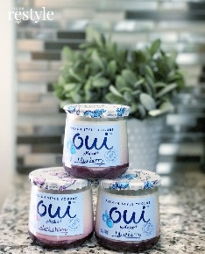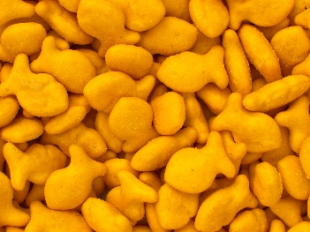  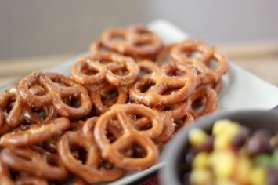 | 