Butterfly Life Cycle Yoga 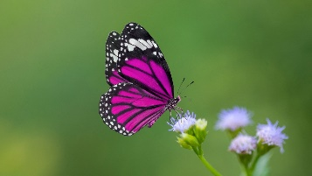

1.
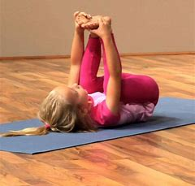 Curl up like an egg.
2.
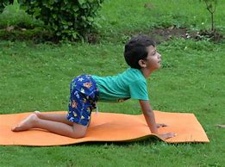 Crawl Like a Caterpillar.
3.
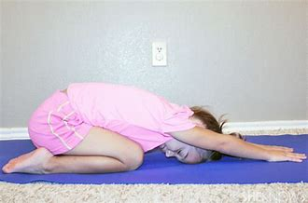 Be as still as a chrysalis.

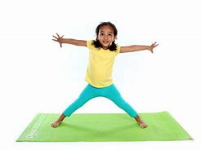 Fly like a butterfly.
~NAMASTE~
How do you feel after becoming a butterfly?

Can you describe what you look like as a butterfly?

Where are you flying to? Why?

