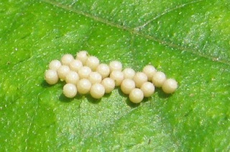  Egg | 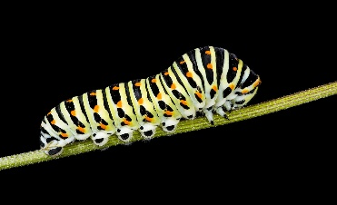  Caterpillar | 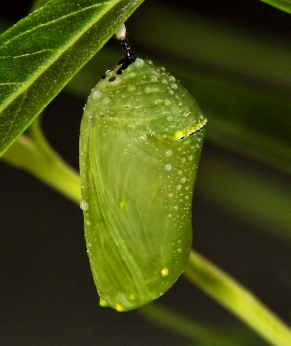  This Photo by Unknown Author is licensed under CC BY  Chrysalis | 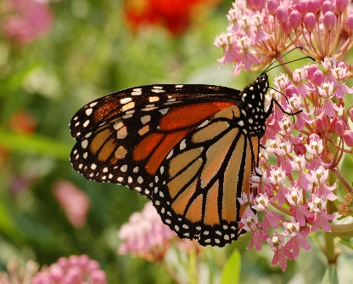  Butterfly
Butterfly Life Cycle (Please Print)
Metamorphosis: The process of an amphibian or insect changing form in stages, from egg to adult.
The butterfly begins as an egg. The caterpillar hatches from the egg and searches for food. When it is ready the caterpillar forms a cocoon/chrysalis and transforms into a butterfly. When the transformation is complete the butterfly breaks out of the chrysalis and flies to find nectar.
A.

B: Draw. Recreate the life cycle of a butterfly.
Egg | Caterpillar | Chrysalis | Butterfly

