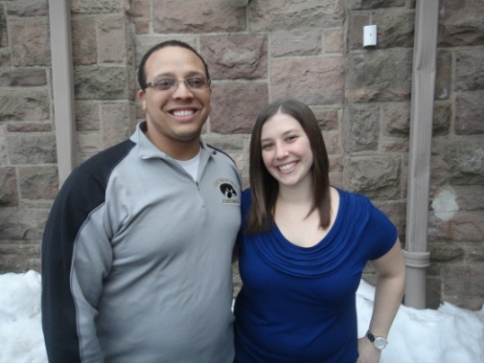 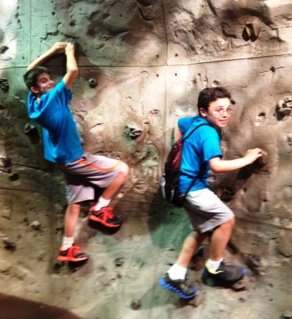 Scott and Jenna-co-directors

The COMMUNITY SCHOOL IN NUTLEY
SUMMER DAY CAMP
6/25 TO 8/17/2018
For Children in grades Kindergarten through Eighth

Dear Parents;

We have an exciting summer planned! We love welcoming our children back for more summer fun, friendships and memories. Each summer, we include new programs and themes to keep your child’s summer experience exciting and new. We pride ourselves in our camp’s main priority of keeping your camper safe and happy, while fostering growth throughout the summer. We are very happy to have Scott Silva and Jenna Bucci return again as our co-directors. Both are certified teachers and have been a part of our summer camp for several years.

In order to give children who attended camp last year, the first opportunity to sign up, we will begin accepting registrations now. Please complete and return the application form with your deposit and registration fee. This is the FIRST STEP in securing a place for your child in the 2018 summer camp program. As camp space is limited, applications will be processed on a first come first served basis.
A check (or cash) in the amount of $155.00 must accompany this registration form. As is our policy, $55 dollars will be applied to a registration fee and the balance of $100 will be applied towards your child’s summer camp tuition. $100 of the deposit will be fully refundable until May 31, 2018 should you choose not to have your child attend camp.

After we receive your application form on or before April 1st, you will receive a packet containing the necessary registration forms, more information about our summer activities and payment information. Celebrating the 50th anniversary of our school, our summer camp tuition will remain the same as last year! Full 8 weeks of summer camp 2040.00, Weekly Rate 280.00 per week, Daily rate 60.00 per day -for less than 5 days.

THE SECOND STEP is to complete and send in the registration packet with the days you wish to enroll your child for camp. We urge you to complete and return the forms in a timely manner as failure to do so may result in your child not having a place in the summer program.

We are also bringing back the C.I.T program which is Counselors in Training. Children have to be at least 13 to apply and would be assisting the counselors. If your child is accepted into the C.I.T. program, there would be a reduced summer camp tuition.

Please fill out the information below and return no later than April 1st 2018
ALONG WITH A $55.00 REGISTRATION FEE AND $100.00 DEPOSIT TO:

THE COMMUNITY SCHOOL IN NUTLEY
100 VINCENT PLACE, NUTLEY, NJ 07110

CSN SUMMER DAY CAMP 2018

FORMS AND DEPOSITS WILL BE ACCEPTED STARTING NOW!

Please Print Clearly:

Child’s Name_____________________ Have you enrolled in our older children’s

camp before? __________

Date of Birth _______________ Age as of 6/25/18_____ Grade in September 2018_______

Parent/Guardian Name and cell#________________________

Parent/Guardian Name and cell#___________________________________________

Child’s Home Address _______________________________________________

Parent’s E-mail address_____________________________________________________

Interested in CIT Program _____ (limited availability)

If you have questions please call 973-661-0789

